**DIGITAL MARKETING**

PROJECT WORK

Project title: Comprehensive Digital Marketing ForboAt Lifestyle

Name: Namburi.V.S.S.R.Trisha

Team ID: LTVIP2025TMID21813

Brand Study

Research Brand Identity

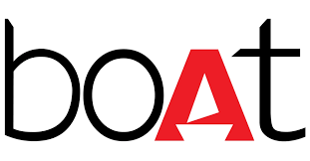boAt Lifestyle, an Indian consumer electronics company, has built a strong brand identity by focusing on affordable, fashionable, and durable audio products and accessories for millennials and Gen Z, emphasizing a sense of community and lifestyle through strategic marketing and product design.

Here's a more detailed breakdown of boAt Lifestyle's brand identity:

Core Values & Target Audience:

* **Focus:**

boAt Lifestyle aims to be an aspirational yet affordable brand for enthusiasts who seek the latest technology, style, and affordability.

* **Target Audience:**

Primarily targets young adults (millennials and Gen Z) with active and fashion-conscious lifestyles.

* **Community:**
* boAt fosters a sense of community among its customers, referred to as "boAtheads," who share a love for music and an active lifestyle.

Key Brand Elements:

* **Product Focus:**

BoAt offers a wide range of audio products, including headphones, earbuds, speakers, and accessories, known for their durability and stylish designs.

* **Affordability & Value:**

boAt's products are positioned as offering high-quality audio experiences at competitive prices, making them accessible to a broader audience.

* **Marketing & Branding:**
  + **Bold & Edgy Image:** boAt's marketing campaigns and brand messaging are known for being bold, edgy, and engaging.
  + **Influencer & Celebrity Endorsements:** The brand leverages collaborations with influencers and celebrities to reach its target audience and build brand awareness.
  + **Digital-First Approach:** boAt operates primarily online, utilizing social media and e-commerce platforms to connect with its customers
* **Product Design:**

boAt emphasizes product design that is not only functional but also aesthetically pleasing and caters to the Indian consumer's preferences and use cases.

* **Durable & Stylish:**

boAt products are known for their durability, especially in harsh conditions, and their stylish designs that elevate audio and mobile accessories to fashion statements.

Key Takeaways:

* boAt Lifestyle has successfully established itself as a leading audio and wearables brand in India by focusing on affordability, style, and a strong brand identity that resonates with its target audience.
* The brand's success is attributed to its understanding of the Indian market, its innovative marketing strategies, and its ability to create products that meet the needs and desires of its customers.
* boAt's focus on building a strong community and fostering a sense of belonging among its customers has also played a crucial role in its success.

Competitor Analysis

Competitor Analysis

boAt Lifestyle faces competition from established and emerging brands in the audio and wearable tech market, including Sony, JBL, Skullcandy, Sennheiser, Apple, Noise, Fire-Boltt, and OnePlus, focusing on affordability, trendy designs, and market-specific strategies.

Here's a more detailed look at boAt's competitive landscape:

Key Competitors:

* **Established Audio Brands:**
  + **Sony:** A global electronics giant known for high-quality audio products and a strong brand reputation, competing in the premium segment.
  + **JBL:** A popular audio brand offering a wide range of products, known for powerful sound and durability, competing in mid-range and premium markets.
  + **Skullcandy:** A lifestyle audio brand targeting younger demographics with trendy designs and affordable prices.
  + **Sennheiser:** Renowned for high-fidelity headphones and professional audio equipment, focusing on audio quality and precision engineering.
  + **Apple:** While known for smartphones, Apple also offers audio products like AirPods and Beats, competing in the premium segment.
* **Emerging Wearable Brands:**
  + **Noise:** A competitor focusing on affordable and stylish wearables, particularly in the Indian market.
  + **Fire-Boltt:** Another brand competing in the wearable space, offering a range of smartwatches and fitness trackers.
  + **OnePlus:** Known for its smartphones, OnePlus also offers a range of audio and wearable products.
* **Other Competitors:**
  + **Samsung:** While primarily known for smartphones, Samsung also offers a range of audio products.
  + **Boult:** A mid-range and affordable product competitor.
  + **P Tron:** Another mid-range and affordable product competitor.
  + **Xiaomi:** A tech giant known for its affordable and innovative products, including wearables.
  + **Nothing:** A company known for its minimalist design and focus on audio products.
  + 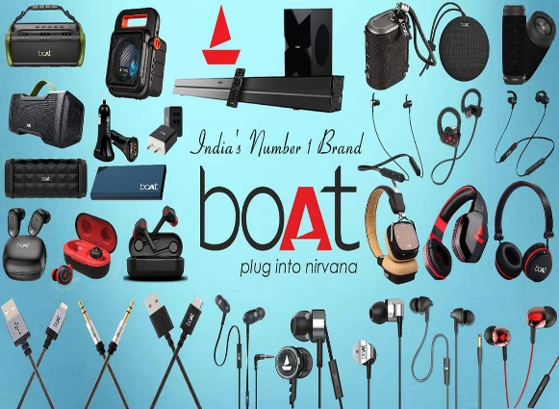**Plantronics:**  A company know n for its headsets and audio accessories

boAt's Competitive Advantages:

* **Affordability:**

boAt focuses on offering stylish and functional audio products at competitive prices, appealing to a broad consumer base.

* **Focus on the Indian Market:**

boAt has a strong presence in the Indian market, understanding the needs and preferences of Indian consumers.

* **Trendy Designs:**

boAt emphasizes trendy and stylish designs, appealing to a younger demographic.

* **Direct-to-Consumer (D2C) Approach:**
* boAt operates with a D2C model, allowing for efficient production and faster response to market trends.
* **Strong Marketing and Brand Building:**

boAt has successfully built a strong brand image and a loyal customer base through effective marketing strategies.

Competitive Strategies:

* **Product Strategy:**

boAt focuses on adapting existing technologies for the Indian market, concentrating on high-demand categories like wireless earphones, headphones, and portable speakers.

* **Pricing Strategy:**

boAt maintains competitive pricing, offering value for money.

* **Distribution Strategy:**

boAt leverages both online and offline channels to reach its target audience.

* **Marketing Strategy:**

boAt employs a combination of online and offline marketing channels, including social media, influencer marketing, and partnerships with celebrities.

Buyer’s/Audience’s persona

Audience’s persona

The boAt Lifestyle buyer persona is primarily a young, tech-savvy individual, aged 18-35, likely male, who is active on social media, interested in music, gaming, and entertainment, and values style and affordability. They see boAt products as a reflection of their vibrant lifestyles and are drawn to the brand's innovative and expressive campaigns.

Here's a more detailed breakdown of the boAt Lifestyle buyer persona:

* **Age:**

Primarily 18-35 years old, with a focus on millennials and Gen Z.

* **Demographics:**
  + **Gender:** Predominantly male.
  + **Education:** Often undergraduates or recent graduates.
  + **Location:** Likely urban dwellers in India.
* **Lifestyle:**
  + **Tech-Savvy:** Active on social media, interested in gaming, music, and entertainment.
  + **Style-Conscious:** Values trendy and fashionable products.
  + **Affordability:** Seeks products that offer good value for money.
  + **Brand Loyalty:** boAtheads (customers) are known for their passion and loyalty to the brand.
* **Interests:**
  + **Music:** boAt's products are often seen as a way to enhance their music listening experience.
  + **Gaming:** boAt offers gaming-focused products and caters to gamers.
  + **Cricket/Movies:** boAt often incorporates these interests into their marketing campaigns.
  + **Fitness:** boAt also offers fitness-related products, such as smartwatches.
* **Marketing Preferences:**
  + **Online:** boAt primarily targets online platforms and social media.
  + **Influencer Marketing:** boAt utilizes collaborations with social media influencers and celebrities.
  + **Community Building:** boAt fosters a sense of community among its customers, referred to as "boAtheads".
* **Product Preferences:**
* **Audio Products:**boAt is known for its headphones, earbuds, speakers, and other audio accessories.
* **Wearables:**boAt also offers smartwatches and other wearable technology.
* **Durability:**boAt emphasizes the durability of its products**.**
* 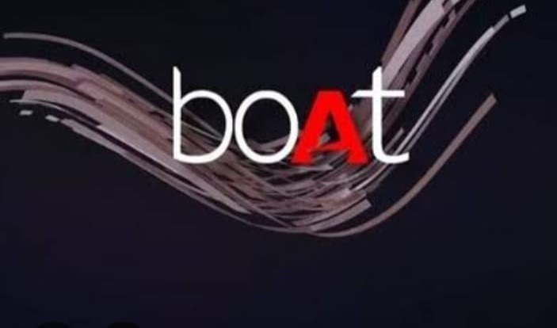**Affordability:**boAt's products are known for being affordable and accessible to a wide range of consumers.

SEO & Keyword Research

SEO Audit

A search engine optimization (SEO) audit for boAt Lifestyle would involve analyzing their website and online presence to identify areas for improvement in their search engine rankings and overall online visibility, focusing on keywords, content, and technical aspects.

Here's a breakdown of what an SEO audit for boAt Lifestyle might entail:

1. Keyword Research and Analysis:

* **Identify relevant keywords:**

Analyze which keywords boAt Lifestyle products and services are associated with, including those used by their target audience (youth, fitness enthusiasts).

* **Evaluate keyword performance:**

Assess which keywords are currently ranking well and which are not, and identify opportunities for improvement.

* **Analyze competitor keywords:**

Look at the keywords their competitors are targeting and identify opportunities to outperform them.

2. On-Page SEO Audit:

* **Website structure and architecture:**

Ensure the website is well-organized and easy for search engines to crawl and index.

* **Content optimization:**

Analyze the quality and relevance of website content, ensuring it is optimized for relevant keywords and user intent.

* **Meta descriptions and titles:**

Ensure meta descriptions and titles are compelling and include relevant keywords.

* **Internal linking:**

Assess the effectiveness of internal linking and ensure it is optimized for search engine optimization.

* **Image optimization:**

Ensure images are optimized with alt tags and file names, which are important for search engine indexing.

* **Page speed:**
* Evaluate page load speed and identify areas for improvement.

3. Off-Page SEO Audit:

* **Backlink analysis:**

Analyze the quality and quantity of backlinks to the website, identifying opportunities to acquire more high-quality backlinks.

* **Social media presence:**

Assess boAt Lifestyle's social media presence and engagement, as social media can influence search engine rankings.

* **Local SEO:**

If boAt Lifestyle has physical stores or services, analyze their local SEO performance and identify opportunities to improve.

4. Technical SEO Audit:

* **Website crawlability:** Ensure the website is easily crawlable by search engines.
* **Sitemap and robots.txt:** Verify that the website has a sitemap and a properly configured robots.txt file.
* **Mobile-friendliness:** Ensure the website is mobile-friendly and optimized for mobile users.
* **Schema markup:** Assess the use of schema markup and identify opportunities to implement it.
* **HTTPS:** Ensure the website uses HTTPS for secure browsing.

5. Recommendations and Implementation:

* **Based on the audit findings, develop a list of actionable recommendations**: for improving boAt Lifestyle's SEO performance.
* **Implement the recommendations**: and track the results to measure the effectiveness of the SEO efforts.

Keyword Research

To conduct keyword research for a "boat lifestyle" focus, start with brainstorming broad topics, then refine them with user-centric phrases and related search terms. Analyze keyword strength, search intent, and competition to identify the most effective keywords for your content and SEO efforts.

Here's a more detailed breakdown:

1. Brainstorming & Identifying Seed Keywords:

* **Start Broad:**

Begin by listing broad topics related to boat lifestyle, such as "boating," "cruising," "fishing," "water sports," and "sailing".

* **Refine with User Intent:**

Think about what people searching for "boat lifestyle" might be looking for. Expand your seed keywords with phrases like "best boats for," "cruising tips," "fishing gear," or "sailing destinations".

* **Consider Different Types of Boats:**

Include keywords related to specific boat types (e.g., "motorboat," "yacht," "kayak," "rowboat").

* **Think about Activities:**

Consider activities associated with boat lifestyle (e.g., "fishing," "scuba diving," "wakeboarding," "snorkeling").

* **Location-Specific Keywords:**

If you're targeting a specific region or area, incorporate location-specific keywords (e.g., "boating in Florida," "fishing in the Bahamas").

2. Keyword Research Tools & Techniques:

* **Keyword Research Tools:**

Utilize tools like Google Keyword Planner, Ahrefs, Semrush, or Moz Keyword Explorer to analyze keyword search volume, difficulty, and related terms.

* **Analyze Search Results:**

Examine the top-ranking pages for your target keywords to understand the types of content that are successful.

* **Competitor Analysis:**

Identify your competitors and analyze their keyword strategy to see what keywords they are targeting and how they are performing.

* **Google Search Console:**

Use Google Search Console to see which keywords your site currently ranks for and identify opportunities for improvement.

* **Quora & Forums:**

Look for questions and discussions related to boat lifestyle on platforms like Quora and forums to identify user needs and pain points.

3. Analyzing Keywords & Defining Goals:

* **Search Volume & Difficulty:**

Focus on keywords with a good balance of search volume and difficulty.

* **Search Intent:**

Ensure that the keywords you choose align with the search intent of your target audience (e.g., informational, navigational, transactional).

* **Keyword Clustering:**

Group related keywords into clusters to create comprehensive content around specific topics.

* **Define Your Goals:**

Determine what you want to achieve with your content (e.g., drive traffic, generate leads, sell products) and choose keywords that align with your goals.

* **Negative Keywords:**

Use negative keywords to exclude irrelevant traffic (e.g., "cheap," "free").

4. Creating Content & Optimizing for Keywords:

* **Create High-Quality Content:**

Focus on creating valuable and engaging content that meets the needs of your target audience.

* **Optimize Pages:**

Incorporate your target keywords naturally into your page titles, headings, meta descriptions, and body text.

* **Use Keywords in Images:**

Use descriptive alt text for images that include your target keywords.

* **Build Backlinks:**

Earn links from other reputable websites to improve your site's authority and ranking.

* **Monitor & Analyze:**

Track your keyword performance and make adjustments to your strategy as needed.

On Page Optimization

To optimize a website for "boat lifestyle" content, focus on on-page SEO by optimizing titles, meta descriptions, headings, image alt text, and internal linking, ensuring fast page speed, and creating high-quality, relevant content that uses keywords related to the boat lifestyle.

Here's a more detailed breakdown:

1. Keyword Research & Content Strategy:

* **Identify relevant keywords:**

Research terms people use when searching for boat-related information, activities, and products (e.g., "boating trips," "best fishing boats," "boat accessories," "water sports").

* **Create high-quality content:**

Develop informative and engaging content that caters to the target audience's interests and needs.

* **Use keywords naturally:**

Integrate keywords into your content, titles, headings, and meta descriptions, but avoid keyword stuffing.

2. On-Page Optimization Techniques:

* **Optimize Titles and Meta Descriptions:**
  + **Title tags:** Craft compelling and informative title tags that include your primary keyword and entice users to click.
  + **Meta descriptions:** Write concise and descriptive meta descriptions that accurately summarize the page content and encourage clicks.
* **Optimize Headings (H1-H6):**
  + **Structure content with headings:** Use headings to organize your content logically and highlight important information.
  + **Include keywords in headings:** Incorporate relevant keywords into your headings to signal their importance to search engines.
* **Optimize Image Alt Text:**
  + **Describe images:** Use descriptive alt text for images, including relevant keywords, to help search engines understand the image content.
* **Optimize Page Speed:**
  + **Minimize image sizes:** Reduce the size of images without compromising quality to improve page load times.
  + **Use a fast hosting provider:** Choose a hosting provider that offers fast servers and high uptime.
  + **Use a Content Delivery Network (CDN):** Distribute your website content across multiple servers to improve page load times for users in different locations.
* **Internal Linking:**
  + **Link to relevant pages:** Link to other relevant pages on your website to help users navigate and explore your content.
* **Mobile Optimization:**
  + **Ensure responsive design:** Make sure your website is mobile-friendly and displays correctly on all devices.

3. Tools for On-Page Optimization:

* **Google PageSpeed Insights:**

Use this tool to analyze your website's page speed and receive recommendations for improvement.

* **Google Search Console:**

Monitor your website's performance in search results and identify any issues that need to be addressed.

* **SEO plugins (for WordPress):**

Use SEO plugins like Yoast SEO or Rank Math to help optimize your website's content and structure.

By implementing these on-page optimization techniques, you can improve your website's visibility in search results and attract more traffic from users interested in the boat lifestyle.

Content Ideas and Marketing strategies

Content Idea Generation & Strategy

To market "boAt lifestyle" effectively, focus on content that resonates with young, active consumers, highlighting affordability, style, and self-expression through music and adventure, leveraging social media, influencer collaborations, and creating a strong online community.

Here's a breakdown of content ideas and marketing strategies for "boAt lifestyle":

Content Ideas:

* **Product-focused:**
  + **High-quality product videos:** Showcasing the design, features, and performance of boAt products in various settings (gym, commute, travel, etc.).
  + **Unboxing and review videos:** Collaborate with influencers and users to create engaging unboxing and review content.
  + **Product comparison videos:** Compare boAt products with competitors, highlighting their unique selling points.
  + **"How-to" tutorials:** Demonstrate how to use boAt products effectively, troubleshoot common issues, and personalize settings.
* **Lifestyle-focused:**
  + **Content that aligns with the brand's values:** Focus on self-expression, adventure, music, and a vibrant lifestyle.
  + **User-generated content:** Encourage users to share their experiences with boAt products and tag the brand on social media.
  + **"Day in the life" videos:** Showcase how boAt products integrate into the daily lives of young, active consumers.
  + **Behind-the-scenes content:** Provide glimpses into the boAt brand's creative process, product development, and team culture.
* **Community-focused:**
  + **"boAtheads" (community) content:** Create content that fosters a sense of belonging and encourages interaction among boAt users.
  + **Interactive polls and quizzes:** Engage with followers on social media by asking questions and running polls related to their favorite music, activities, and lifestyle.
  + **Live Q&A sessions:** Host live Q&A sessions with boAt representatives or influencers to address user queries and build relationships.
  + 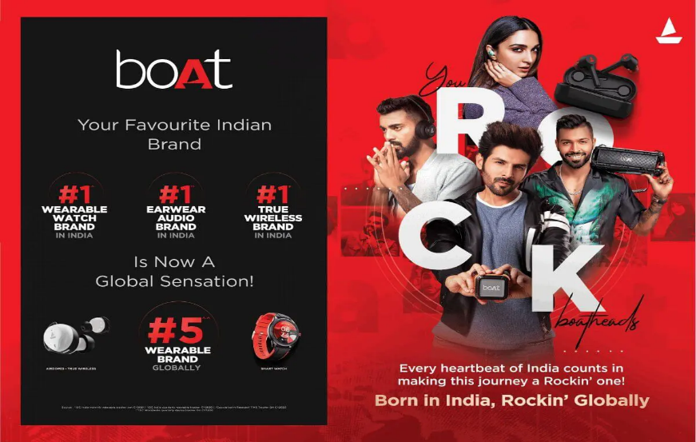**Exclusive content for community members:** Offer early access to new products, promotions, and events for loyal boAtheads.

Marketing Strategies

* **Social Media Marketing:**
  + **Create a strong social media presence:** Focus on platforms like Instagram, Facebook, and YouTube, where young consumers are most active.
  + **Run engaging campaigns:** Use visually appealing content, interactive features, and targeted ads to reach the right audience.
  + **Collaborate with influencers:** Partner with relevant influencers who have a genuine connection with the brand's identity.
  + **Use relevant hashtags:** Create and promote brand-specific hashtags to build community and track engagement.
  + **Run contests and giveaways:** Encourage user engagement by offering prizes and exclusive content.
* **Content Marketing:**
  + **Create a blog or website:** Share valuable content related to audio technology, music, lifestyle, and boAt products.
  + **Develop email marketing campaigns:** Reach out to subscribers with product updates, promotions, and exclusive content.
  + **Create podcasts or audio content:** Share insights, interviews, and music playlists with a target audience.
* **Search Engine Optimization (SEO):**
  + **Optimize website and content for relevant keywords:** Ensure that your website and content are easily discoverable by search engines.
  + **Build backlinks from reputable websites:** Increase your website's authority and credibility.
* **Brand Ambassadors:**
  + **Partner with relevant brand ambassadors:** Collaborate with celebrities, athletes, and other public figures who resonate with your target audience.
* **Customer Service:**
  + **Provide excellent customer service:** Ensure that customers have a positive experience with boAt products and services.
  + **Respond to customer queries promptly and professionally:** Address customer concerns and build trust.

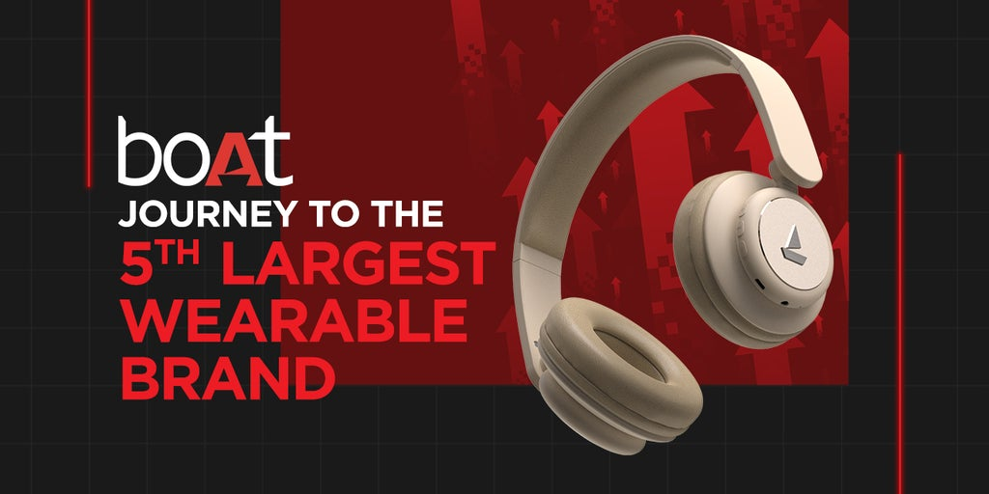

Content Creation and Curation:

To create and curate content for a "boat lifestyle" brand, focus on showcasing the freedom, adventure, and community aspects of boating through visually appealing images, engaging stories, and informative guides, while also highlighting the brand's products and values.

Here's a breakdown of content creation and curation strategies for a "boat lifestyle" brand:

1. Content Creation:

* **Visual Content:**
  + **High-Quality Photography & Videography:** Capture stunning images and videos of boats on the water, sunsets, and people enjoying boating activities.
  + **Action Shots:** Showcase the thrill of boating, like wakeboarding, fishing, or waterskiing.
  + **Lifestyle Content:** Depict the relaxed and social aspects of boating, such as family gatherings, picnics, or enjoying drinks on the deck.
  + **Product Focus:** Feature the brand's products in action, emphasizing their functionality, style, and durability.
* **Written Content:**
  + **Blog Posts:** Share informative articles about boating tips, destinations, safety, and maintenance.
  + **Stories:** Tell compelling stories about boating adventures, challenges, and triumphs.
  + **Guides:** Create step-by-step guides for different boating activities, such as fishing, kayaking, or sailing.
  + **Testimonials:** Feature customer stories and reviews to build trust and credibility.
* **Interactive Content:**
  + **Polls and Quizzes:** Engage with followers by asking questions and running polls related to boating.
  + **Hashtag Campaigns:** Encourage user-generated content by launching hashtag campaigns that showcase boating experiences.
  + **Live Streams:** Host live Q&A sessions with boating experts or showcase boat shows and events.

2. Content Curation:

* **Identify Relevant Content:**

Search for and curate content from other boating blogs, social media accounts, and websites that align with the brand's values and target audience.

* **Share and Promote:**

Repurpose and share curated content on the brand's social media channels and website.

* **Engage with Followers:**

Respond to comments and questions, and participate in relevant discussions.

* **Collaborate with Influencers:**

Partner with boating influencers to reach a wider audience and build credibility.

* **Track and Analyze:**

Monitor content performance and make adjustments as needed to optimize engagement and reach.

3. Key Themes to Emphasize:

* **Freedom and Adventure:** Highlight the sense of freedom and adventure that boating provides.
* **Community:** Showcase the social aspect of boating and the community of boaters.
* **Relaxation and Recreation:** Emphasize the relaxing and recreational aspects of boating.
* **Product Focus:** Highlight the brand's products and their benefits in a natural and engaging way.
* **Safety and Responsibility:** Promote responsible boating practices and safety tips.

4. Examples of Content Ideas:

* "A Day on the Water: A Family Boating Adventure"
* "Top 5 Boating Destinations for Beginners"
* "How to Choose the Right Boat for Your Needs"
* "Boating Safety Tips for a Worry-Free Trip"
* "The Ultimate Boating Gear Guide"
* "Meet the Boater: [Name] and Their Boating Journey"
* "Boating Q&A: Ask the Experts"
* "Boating Challenges: Can You Beat Our Time?"
* "Boating Events: Join Us for a Day of

Post Creation

To create a compelling post about a "boat lifestyle," focus on the freedom, adventure, and unique experiences it offers, using high-quality visuals and engaging captions that evoke a sense of escapism and relaxation.

Here's a breakdown of how to create a post about a boat lifestyle:

1. Visual Appeal:

* **High-Quality Images/Videos:**

Use photos and videos that showcase the beauty of the water, the boat itself, and the activities you enjoy on it (fishing, swimming, sunbathing, etc.).

* **Variety:**

Include a mix of shots: wide landscapes, close-ups of details, and action shots.

* **Natural Lighting:**

Opt for natural lighting whenever possible to capture the vibrant colors of the water and sky.

* **Consider the Platform:**

Tailor the visuals to the platform you're posting on (e.g., Instagram, Facebook, etc.).

2. Engaging Captions:

* **Tell a Story:**

Share a personal anecdote or experience that highlights the joy of boating.

* **Focus on the "Why":**

Instead of just listing activities, explain why you love this lifestyle (e.g., "The peace and quiet of the water," "The thrill of exploring new places," "The feeling of freedom").

* **Use Strong Verbs and Descriptive Language:**

Instead of "We went boating," try "We drifted into a world of tranquility" or "We sailed towards the horizon".

* **Ask Questions:**

Encourage engagement by asking questions related to boating experiences or preferences.

* **Hashtags:**

Use relevant hashtags to increase visibility (e.g., #boatlifestyle, #boating, #waterlife, #sailing, #fishing, #travel).

* **Location Tag:**

Tag the location where the photo/video was taken to help others discover similar spots.

3. Content Ideas:

* **A Day on the Water:** Showcase a typical day, from sunrise to sunset, highlighting different activities and moments.
* **"My Favorite Thing About Boating":** Share your personal favorite aspect of the boat lifestyle.
* **"Boating Tips":** Offer helpful advice or tips for beginners or experienced boaters.
* **"Boating Gear":** Feature your favorite gear and why you love it.
* **"Boating Destinations":** Promote beautiful locations that are perfect for boating and water activities.
* **"Behind the Scenes":** Share glimpses of the maintenance and upkeep of your boat.
* **"Boating with Friends/Family":** Highlight the social aspect of boating and the joy of sharing experiences with loved ones.

Example Post:

* **Image:** A stunning photo of a sunset over the water with a boat in the foreground.
* **Caption:** "There's something magical about watching the sun dip below the horizon from the deck of a boat. The water is calm, the air is fresh, and the world feels a little bit smaller. This is my happy place. What's your favorite thing about boating? #boatlifestyle #sunset #waterlife #travel"

Designs/Video Editing

To create engaging video edits showcasing a boat lifestyle, focus on capturing diverse footage, organizing your clips, and using editing techniques to tell a compelling story, while incorporating elements like establishing shots, match cuts, and appropriate transitions.

Here's a more detailed breakdown:

1. Capture High-Quality Footage:

* **Variety is Key:**

Aim for a mix of shots: wide shots of the landscape, close-ups of activities, and dynamic shots of movement.

* **Storytelling Shots:**

Include shots that tell a story, such as someone fishing, cooking on deck, or relaxing with a book.

* **Consider the Environment:**

Capture the beauty of the water, the sun, and the sky.

* **Sound is Important:**

Use a microphone to record clear audio, and consider using background music that complements the visuals.

2. Organize Your Footage:

* **Create Folders:** Organize your footage into folders based on location, activity, or type of shot.
* **Use Keywords:** Tag your clips with keywords to make it easier to find them later.

3. Plan Your Edit:

* **Outline the Story:** Decide what story you want to tell with your video (e.g., a day on the water, a fishing trip, a relaxing weekend).
* **Choose Your Clips:** Select the clips that best support your story.
* **Consider Pacing:** Decide how quickly or slowly you want the video to move.

4. Editing Techniques:

* **Establishing Shots:** Use wide shots at the beginning of the video to set the scene.
* **Match Cuts:** Use match cuts to create a smooth flow between shots.
* **Transitions:** Use transitions to smoothly move between scenes.
* **Music and Sound Effects:** Use music and sound effects to enhance the mood of your video.
* **Text and Graphics:** Use text and graphics to add information or emphasize key moments.

5. Software Options:

* **Free Options:**

Consider using free video editing software like DaVinci Resolve or HitFilm Express.

* **Paid Options:**

For more advanced features, consider paid options like Adobe Premiere Pro or Final Cut Pro.

Tips for a Boat Lifestyle Video:

* **Showcase the Activities:** Highlight the activities that make a boat lifestyle special, such as fishing, swimming, kayaking, or simply relaxing on deck.
* **Emphasize the Beauty of Nature:** Capture the beauty of the water, the sun, and the sky.
* **Tell a Story:** Use your video to tell a story about your experiences on the water.
* **Be Authentic:** Share your real experiences and emotions.
* **Use High-Quality Equipment:** Invest in good quality equipment, such as a waterproof camera and a microphone.
* **Edit Professionally:** Take the time to edit your video professionally, so it looks polished and engaging.

Social Media Ad Campaigns

To create effective social media ad campaigns for a "boat lifestyle" brand, focus on visuals, target boating enthusiasts, and use platforms like Instagram and YouTube to showcase the freedom and adventure associated with boating.

Here's a more detailed breakdown:

1. Target Audience and Platform Selection:

* **Identify your ideal customer:**

Who are you trying to reach? Are they young families, adventure seekers, or luxury vacationers?

* **Choose the right platforms:**
  + **Instagram:** Ideal for visually-driven content like stunning photos and videos of boats, destinations, and boating activities.
  + **YouTube:** Perfect for longer-form content like boat reviews, how-to videos, and travel vlogs showcasing boating experiences.
  + **Facebook:** Good for broader reach and community engagement, especially with groups focused on boating and water sports.
* **Consider other platforms:**

Explore platforms like TikTok for short, engaging content and Pinterest for visual inspiration.

2. Content Strategy:

* **Visually appealing content:**

Use high-quality photos and videos that capture the beauty and excitement of boating.

* **Focus on the lifestyle:**

Showcase the freedom, adventure, and relaxation associated with boating, not just the product itself.

* **Create a variety of content:**
  + **Behind-the-scenes:** Share glimpses of your operations, boat maintenance, and team stories.
  + **Customer testimonials:** Feature happy boat owners and their experiences.
  + **Travel vlogs:** Document boating trips and destinations.
  + **How-to videos:** Offer tips and advice on boating skills and safety.
  + **Promotional content:** Highlight special offers, new models, and upcoming events.
* **Use relevant hashtags:**

Research popular boating hashtags and use them strategically to increase visibility.

3. Social Media Advertising:

* **Target your ads:**

Use social media platform targeting options to reach specific demographics, interests, and behaviors.

* **Create compelling ad copy:**

Use clear and concise language that highlights the benefits of your products or services.

* **Use a variety of ad formats:**

Experiment with different ad types, such as image ads, video ads, and carousel ads.

* **Track your results:**

Monitor your ad performance and make adjustments as needed to optimize your campaigns.

* **Collaborate with influencers:**

Partner with boating influencers who have a strong following and resonate with your target audience.

4. Engagement and Community Building:

* **Respond to comments and messages:** Engage with your audience and build relationships.
* **Run contests and giveaways:** Encourage participation and generate excitement.
* **Create a sense of community:** Foster a positive and welcoming environment for your followers.
* **Build an email list:** Collect email addresses to nurture leads and keep your audience informed about new products, promotions, and events.

Example:

* **Visual:**

A stunning photo of a boat sailing on a calm lake with the sun setting in the background.

* **Caption:**

"Escape the ordinary and embrace the freedom of the open water. Discover your next boating adventure with us!".

* **Hashtags:**

#boatinglife #boatingadventures #lake #summer #travel #freedom #boatlife #water.

Email Campaigns

To create effective email campaigns for boAt Lifestyle, focus on building a targeted email list, understanding your audience and goals, crafting compelling content, and using technology wisely.

Here's a more detailed breakdown:

1. Build a Targeted Email List:

* **Gather Data:**

Collect email addresses through website forms, social media promotions, or in-person events.

* **Segmentation:**

Categorize your subscribers based on demographics, interests, purchase history, or engagement levels to personalize your messages.

2. Know Your Goals:

* **Define Objectives:**

Determine what you want to achieve with your email campaigns (e.g., increase sales, promote new products, build brand awareness).

* **Set Metrics:**

Establish key performance indicators (KPIs) to track the success of your campaigns (e.g., open rate, click-through rate, conversion rate).

3. Understand Your Audience:

* **Customer Personas:**

Develop detailed profiles of your target audience to tailor your messaging and content.

* **Personalize Emails:**

Use subscriber data to create personalized subject lines, email copy, and product recommendations.

4. Craft Compelling Content:

* **Engaging Subject Lines:** Write attention-grabbing subject lines that entice recipients to open your emails.
* **Clear and Concise Copy:** Use easy-to-read language and a clear call to action in your email body.
* **High-Quality Visuals:** Include relevant and visually appealing images or videos to enhance your emails.

5. Use Technology Wisely:

* **Email Marketing Platform:**

Utilize an email marketing platform to automate tasks, track results, and manage your email list.

* **A/B Testing:**

Experiment with different subject lines, email copy, and layouts to optimize your campaigns.

* **Analytics:**

Monitor your email campaign performance and make adjustments based on the data.

6. Plan Emails and Follow-ups:

* **Email Frequency:**

Determine the optimal frequency for sending emails to your audience, avoiding over-saturation.

* **Follow-up Strategy:**

Plan follow-up emails for subscribers who haven't opened or clicked on your initial emails.

7. Examples of Email Campaigns for boAt Lifestyle:

* **New Product Launch:**

Announce new audio products with compelling visuals and a call to action to pre-order or purchase.

* **Promotional Offers:**

Share exclusive discounts, limited-time deals, or free shipping promotions.

* **Lifestyle Content:**

Share articles, videos, or social media posts related to music, technology, or the boAt lifestyle.

* **Customer Appreciation:**

Send personalized thank you emails to loyal customers or offer exclusive perks.

THANK YOU

"Dear boAt Lifestyle, Thank you for the amazing products and the positive experience. I appreciate the quality and style you offer. Keep up the great work!"

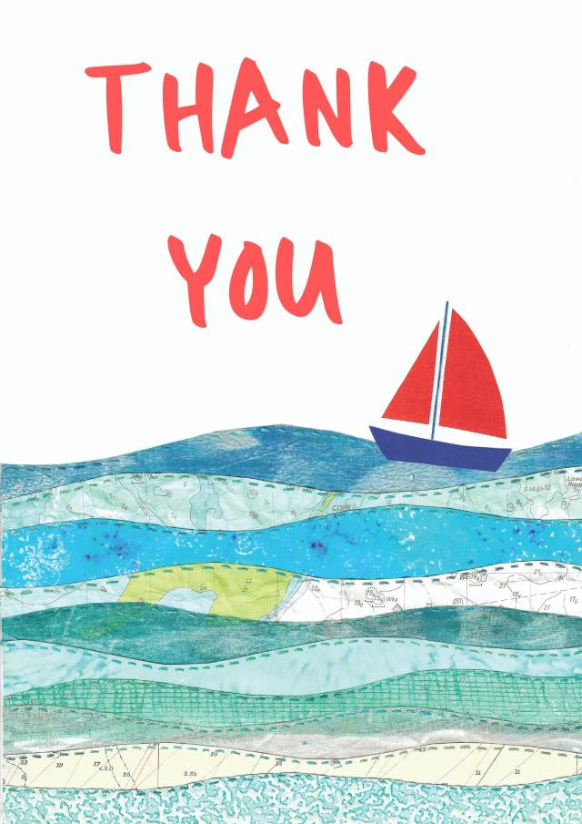"Dear boAt Lifestyle, I wanted to express my gratitude for [mention specific product or experience, e.g., the amazing sound quality of my new headphones, the helpful customer service]. It's been a great experience, and I appreciate your commitment to quality."